HOLE SPONSOR REGISTRATION  Hole Sponsors will have their name prominently displayed on the sign for their hole. Cart Sponsors will have their name displayed on one golf cart. Both Hole and Cart Sponsors will be included on a Sponsor Board to be prominently displayed at all Nativity K of C and Nativity Athletic Events.  ____ SPONSOR RAFFLE OR PRIZE  DONATIONS $200  ___SKILL CONTEST SPONSOR $160  Longest Drive – Men’s, Women’s, and, Senior’s; Putting Contest, and  Closest to the Pin  ____HOLE SPONSOR $100  ____CART SPONSOR $40  __ Please accept my contribution of:  __ $50 __ $25 __ Other  My total Contribution _____________  Contact Name ___________________  Company _______________________  Address ________________________ City ______________St____ ZIP ____ Phone ________________  E-mail______________________________  __ I can provide my business logo in a computer file by e-mail. Please contact me as noted above.  Make checks payable to:  Knights of Columbus Council #13105  Mail to: Nativity K of C  7225 Southeastern Avenue  Indianapolis, IN 46239 | K of C Charity Fund  The Nativity K of C Charity Fund is used to fund numerous requests ranging from individual requests to support families or individuals in need. A Charity Committee is responsible for reviewing all requests prior to funding. Examples of requests received since the Nativity KofC was established in 2002 are:  K of C Scholarship Fund  Eagle Scout Projects  Nativity Catholic School  NCYC and WYD Conferences  I/Step Breakfast for Nativity Students  Indiana Special Olympics  Nativity Parish Building Fund  Military Chaplains  Nativity Athletic Committee  Promotes and supports various the youth of the parish through the Catholic Youth Organization. The volunteer committee served close to 600 athletes in different sports: Kickball, Football, Cross Country, Girls and Boys Basketball, Girls and Boys Volleyball, Wrestling, Soccer, and Track.  $8,964 raised in 2023 | NATIVITY  2024 GOLF SCRAMBLE  Friday, September 6th  Smock Golf Course  3910 County Line Rd  Indianapolis, IN  Player Fee: $90.00  $100.00 after 7/31  Sponsor Prize Donation $200  Skill Contest Sponsor $160 Hole Sponsor $100  Cart Sponsor $40  PROCEEDS BENEFIT  NATIVITY K of C CHARITY FUND  AND SUPPORT  NATIVITY CYO ATHLETIC  PROGRAMS
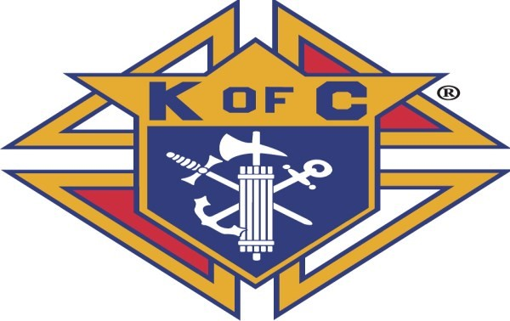  NATIVITY  2024 GOLF SCRAMBLE  DATE: Friday September 6, 2024  Time: Shotgun Start @ 10 AM  Course: Smock Golf Course  3910 County Line Rd  Indianapolis, IN 46237  Player Fee includes:  18 holes of Golf  Cart  Free Beer  Morning Snack, Steak Dinner after Golf  Numerous Door Prizes  Schedule:  8:30 am Registration  10:00 am Shotgun Start  Meal and Prize awards in the  at Smock after Golf  Junior Golfers Welcome  PROCEEDS GO TO  NATIVITY K of C  CHARITY FUND and  NATIVITY ATHLETICS | Smock Golf Course  Smock Golf Course is a publicly owned, daily fee golf and practice facility. With a Silver Course Rating from the Indianapolis Parks and Recreation Association and works hard in maintaining nature in and around the golf course, Smock Golf Course is committed and dedicated to growing the game of golf one golfer at a time.  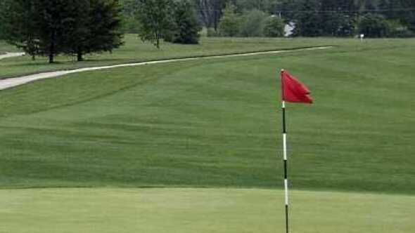  For Additional Information Contact:  Ralph Proctor 317-527-9264  Email: rhproctor2001@yahoo.com  Brian LeBeau at:  blebeau@ptservice.com  Eunsun Waugh at:  eunsunw@gmail.com |  | GOLFER REGISTRATION  Player 1 _______________________  Address________________________  City______________ ST__ Zip______  Phone_______ Email_____________  Player 2________________________  Address________________________  City_______________ ST__ Zip_____  Phone _______ Email_____________  Player 3________________________  Address________________________  City _______________ST__ Zip_____  Phone ________Email____________  Player 4 _______________________  Address _______________________  City _______________ST __Zip_____  Phone _________ Email___________  Make checks payable to:  Knights of Columbus Council #13105  Mail checks and registration to:  Nativity KofC  7225 Southeastern Avenue  Indianapolis, IN 46239

